**Lesson 8 Demo 3**

**Rolling Out an Update for a Deployment**



**Steps to be followed:**

1. Setting up a storage account resource
2. Creating a new file share for the storage account
3. Setting up Azure Cloud Shell
4. Creating a deployment and rolling out an update for it

**Step 1: Setting up a storage account resource**

1. On Create a resource page, search for **Storage account** and select the

**Storage account** resource from the dropdown

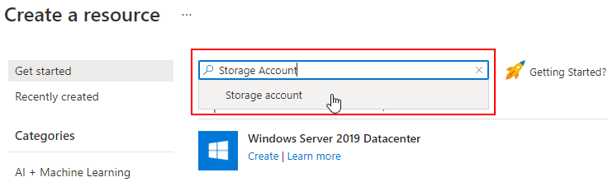

1. On Storage account page, click on the **Create** button to create this resource

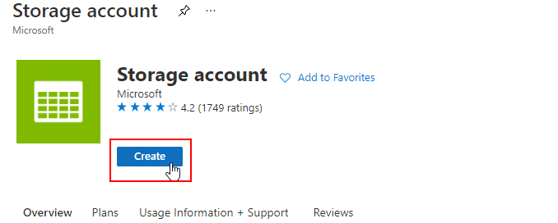

1. On Create a Storage account page, enter the following detailsand click on the **Review + Create** button:

**Storage account name:** **sl20storageaccount**

**Region: West US**

| **Note:** Keep the default value for all the other fields. |
| --- |

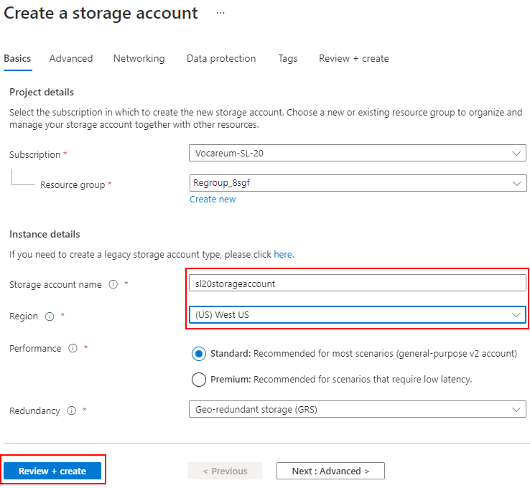

1. Once the validation is complete, click on the **Create** button

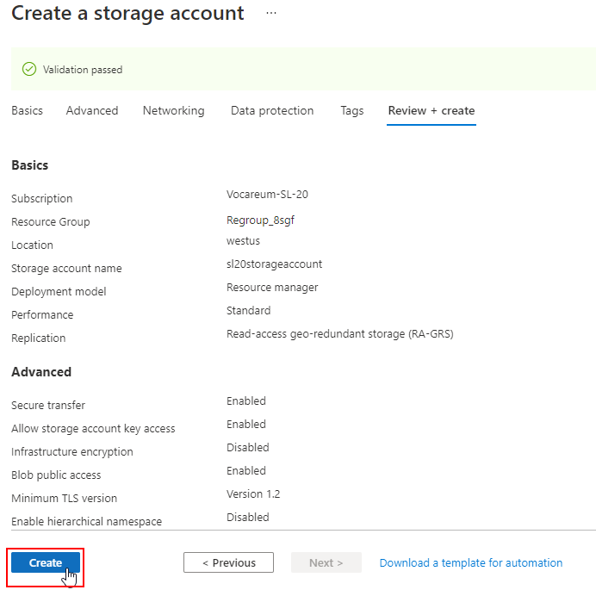

1. Check the newly created resource on the **Resource group** page

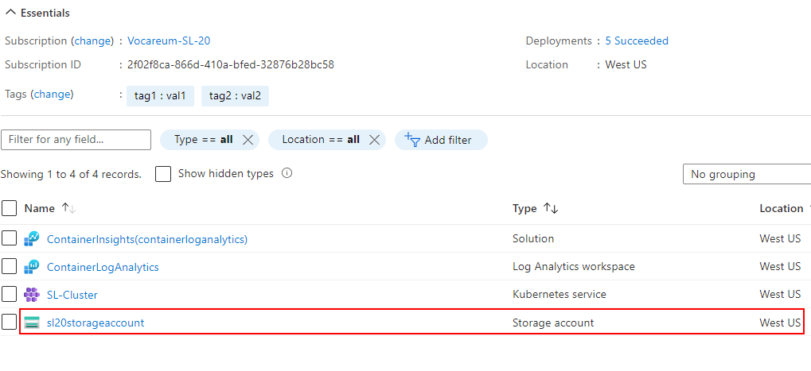

**Step 2: Creating a new file share for the storage account**

1. In the storage account resource, go to **File Shares** and click on the **File share** button

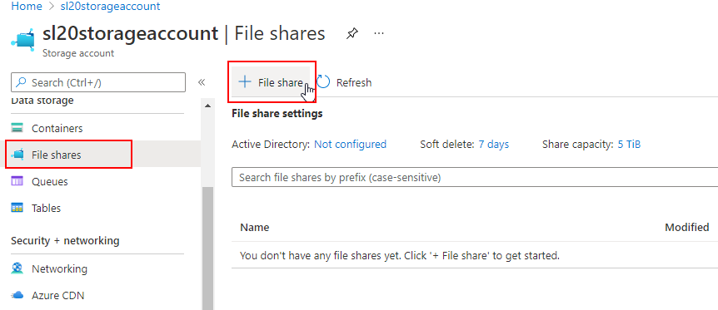

1. In the **New** **file share** pop-up window, enter the following details and click on the **Create** button:

**Name: slfileshare**

**Quota: 10**

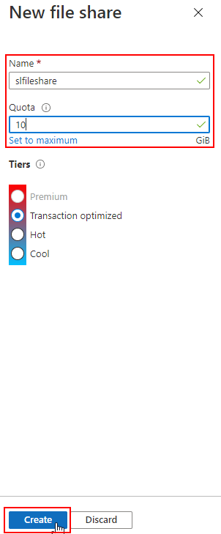



1. Check the newly created **slfileshare** under **File shares** section of the storage account

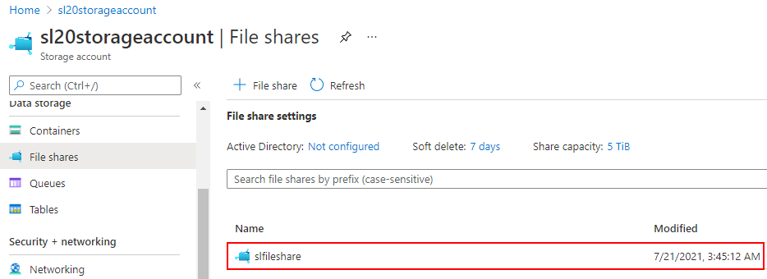

**Step 3: Setting up Azure Cloud Shell**

1. Click on the **Cloud Shell icon** from the top navigation bar

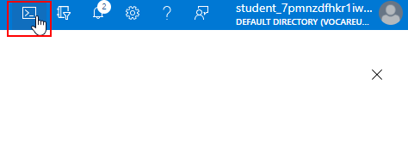

1. On the Azure Cloud Shell window, click on the **Bash** link

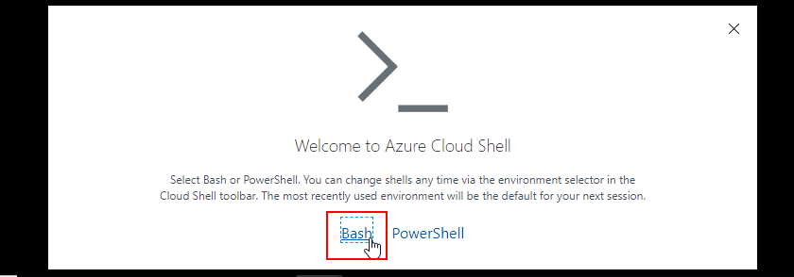

1. On the next screen, click on **Show advanced settings** link

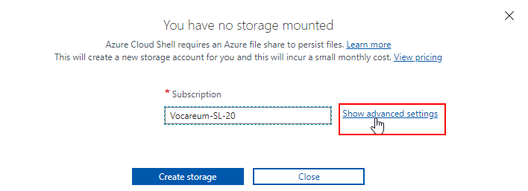

1. On the **Advanced settings** window, select the **Use existing** option for **Storage account** and enter **sl20storageaccount** as the storage account name
2. For **File share** field, select the **Use existing** option, enter **slfileshare** as the file share name, and click on the **Attach storage** button

| **Note:** Make sure the **Cloud Shell region** is **West US** as all resources are created for the West US region |
| --- |

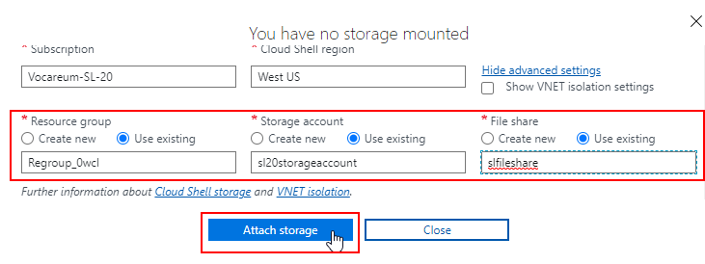

1. Go to **Overview** section in the **SL-Cluster** and click on the **Connect** button

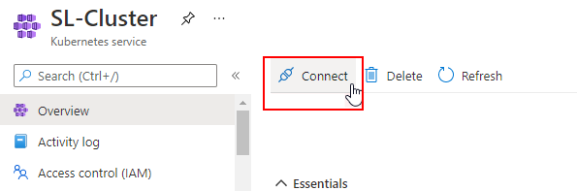

1. Copy the commands from **Connect to SL-Cluster** pop-up window

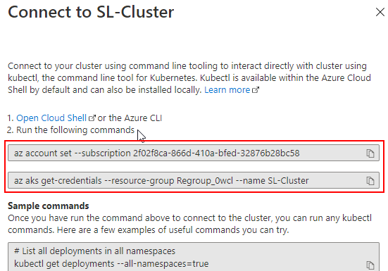

1. Navigate back to the **BASH** window and paste the commands copied in **Step 3.7**

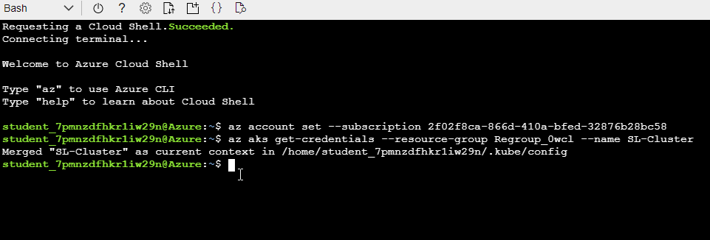

**Step 4: Creating a deployment and rolling out an update for it**

1. Navigate to the **Workloads** section in **SL-Cluster**, select the **Deployments** tab, and click on the **Add** button
2. Add the following code to the **YAML** section and click on the **Add** button:

***apiVersion: apps/v1***

***kind: Deployment***

***metadata:***

***name: second-deployment***

***namespace: first-namespace***

***labels:***

***app: second-deployment***

***spec:***

***replicas: 3***

***selector:***

***matchLabels:***

***app: second-deployment***

***template:***

***metadata:***

***labels:***

***app: second-deployment***

***spec:***

***containers:***

***- name: nginx-container***

***image: nginx:1.14.2***

***ports:***

***- containerPort: 80***

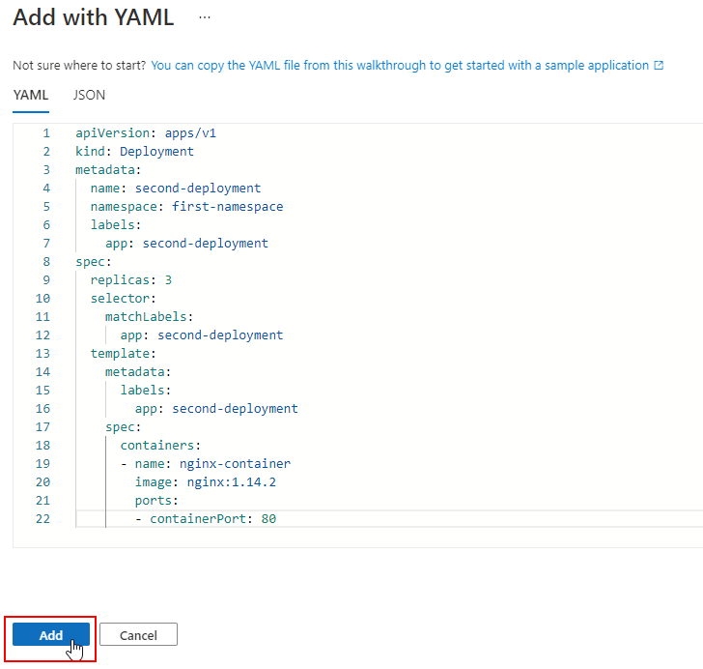

1. Go to the **BASH** screen and run the following commands to check the newly created second-deployment:

***kubectl get deployments -n first-namespace***

***kubectl get rs -n first-namespace***

***kubectl get pods --show-labels -n first-namespace***

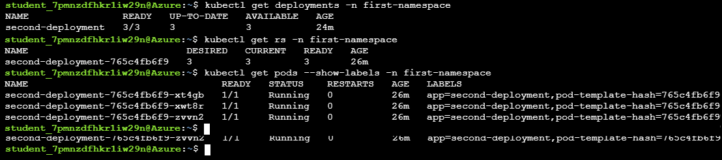

1. Use the following command to update the **nginx image version** to **1.16.1** in the second-deployment:

***kubectl set image deployment/second-deployment \***

***-n first-namespace nginx-container=nginx:1.16.1 --record***



1. Check the rollout status of the second-deployment:

***kubectl rollout status deployment/second-deployment -n first-namespace***



1. Execute the following command to describe the updated second-deployment:

***kubectl describe deployments second-deployment -n first-namespace***

